LIDAR Technologies and Systems June 6-10 Univ. of Dayton
Instructors:
Paul McManamon, paul@excitingtechnology.com
Edward Watson, edward.watson@vao-llc.com
Target Audience: engineers, scientists, managers of EO Sensor systems development.
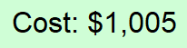
June 6-10
Mon | Tues | Wed | Thurs | Fri
 | 9am-12pm | 9am-12pm | 9am-12pm | 9am-12pm
1-4pm | 1-4pm | 1-4pm | 1-4pm
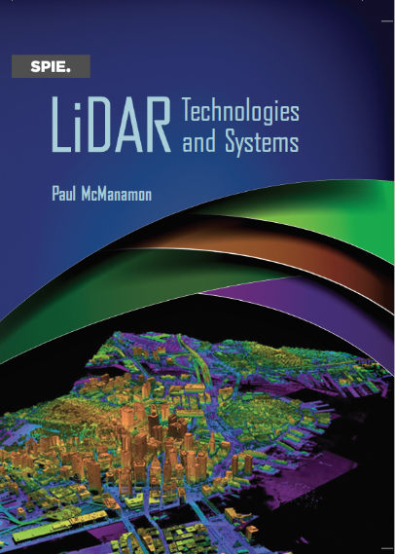
Venue: Live Lectures via Zoom or On-site option
Fitz Hall 5th floor, 1519 Brown Street, Dayton, Ohio 45469

Course Outline:
Introduction
History of Lidar
Types of Lidar
Atmospheric effects on Lidar
Lidar Range Equation, signal-to-noise ratio, and basic detection theory
Laser sources for Lidar
Lidar Receiver hardware
Beam Steering for Lidar
Lidar Processing
Testing of Lidars, and Lidar Performance Metrics
Lidar Application Design Examples

Design Exercise – Design a lidar

Books: Textbook: Lidar Technology and Systems, by Paul McManamon
Additional Material: Field Guide to Lidar, by Paul McManamon

Course information:
2022 summer 1st session; EOP 595-62 (Special Problems) Introduction to LIDAR (CRN 3880),
Register for 1 academic credit hour or 2.4 CEUs (continuing education units) professional development. The first 28 people signing up for online participation will be assured a spot in the course. Once the in person registrations are complete more online participation may be allowed.

